Accident / Injury / Illness Report
(OSHA Form 301 Equivalent)

Instructions: Complete this form as soon as possible (no more than 7 days) after any incident that results in an injury, illness or near miss. Collect as much information as possible and then submit report or draft to the Safety Department and a stamped copy to Human Resources as soon as possible. Retain document for 5 years following the year to which it pertains.

This is a report of a:  Death  Lost Time  Medical Treatment  First Aid Only  Near Miss
Date of incident: | Report #: | 300 Log Case #:  (if applicable)

Step 1: Injured employee (complete this part for each injured employee)
Name:  Address :  Phone:  Emergency Contact:  Name:  Phone: |  | ❑ Male  Female |  | This employee works:   Regular full time   Regular part time   Giles   Temporary
 |  | DOB:
 |  | DOH:
Facility/Department: | Job title at time of incident: | Months doing this job: | Time employee’s shift began:
Part of body affected: (shade all that apply)  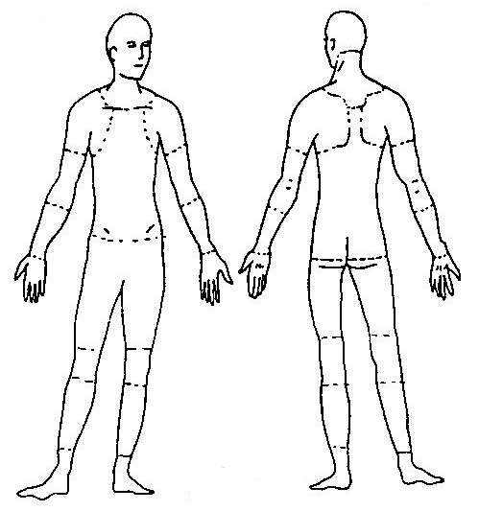 |  | Nature of injury: (most serious one)   Abrasion, scrapes   Amputation   Broken bone   Bruise   Burn (heat)   Burn (chemical)   Concussion (to the head)   Crushing Injury   Cut, laceration, puncture   Hernia   Illness   Sprain, strain   Damage to a body system:   Other ___________ | What object or substance directly harmed the employee?

Step 2: Describe the incident
Location of the incident: | Time of event:  am  pm
What part of employee’s workday?  Entering or leaving work  Doing normal work activities
❑ During meal period  During break  Working overtime  Other____________
Names (first and last) of witnesses and statements (Contact Information if applicable):

Attachments  (#, Yes or No) | Written witness statements: | Photographs: | Maps / drawings:
What personal protective equipment was being used (if any)?

❑ Safety Glasses  Safety Shoes  Smocks  Hair/Beard Nets  Gloves  Other _______________
Employee’s statement: Describe, step-by-step the events that led up to the accident/injury. Include names of any machines, parts, objects, tools, materials and other important details.

Description continued on attached sheets: 

Accepted Recommended Medical Treatment:  Yes  No  N/A

If yes, employee must be informed to request mandatory post-accident alcohol/drug screening:  Yes  No

If yes, where was employee taken for treatment: _______________________________________
Name of physician or other health care professional: ____________________________________
Was employee treated in an emergency room?  Yes  No
Was employee hospitalized overnight as an in-patient?  Yes  No

Employee Signature/Date:___________________________________

Step 3: Why did the incident happen?
Unsafe workplace conditions: (Check all that apply)   Inadequate guard   Unguarded hazard   Safety device is defective   Tool or equipment defective   Workstation layout is hazardous   Unsafe lighting   Unsafe ventilation   Lack of needed personal protective equipment   Lack of appropriate equipment / tools   Unsafe clothing   No training or insufficient training   Other: _____________________________ | Unsafe acts by people: (Check all that apply)   Operating without permission   Operating at unsafe speed   Servicing equipment that has power to it   Making a safety device inoperative   Using defective equipment   Using equipment in an unapproved way   Unsafe lifting   Taking an unsafe position or posture   Distraction, teasing, horseplay   Failure to wear personal protective equipment   Failure to use the available equipment / tools   Other: __________________________________
Were the unsafe acts or conditions reported prior to the incident?  Yes  No
Have there been similar incidents or near misses prior to this one?  Yes  No
Other Comments:

Step 4: How can future incidents be prevented?
What changes do you suggest to prevent this incident/near miss from happening again?

❑ Stop this activity  Guard the hazard  Train the employee(s)  Train the supervisor(s)

❑ Redesign task steps  Redesign work station  Write a new policy/rule  Enforce existing policy

❑ Routinely inspect for the hazard  Personal Protective Equipment  Other: ____________________

What corrective action should be (or has been) done to carry out the suggestion(s) checked above?

Description continued on attached sheets: 

Has corrective action(s) been implemented and if so, date of implementation?  Yes  No Date(s):______________________

Step 5: Who completed and reviewed this form? (Please Print)
Written by:  Department: | Title:  Date:
Names of investigation team members (if applicable):

Has Temporary Agency been notified of accident/injury:  Yes  No Initials/Date:_________________

PC365 Report # (Manpower): ___________________________
Reviewed by:

Name: ______________________ Title: _________________________ Date: __________

Name: ______________________ Title: _________________________ Date:__________

Name: ______________________ Title: _________________________ Date:__________

Effective on Jan.1, 2015, under revised rule, employers will be required to notify the NCDOL
OSH Division of work-related fatalities within eight hours and all work-related
in-patient hospitalizations, amputations or losses of an eye within 24 hours.

